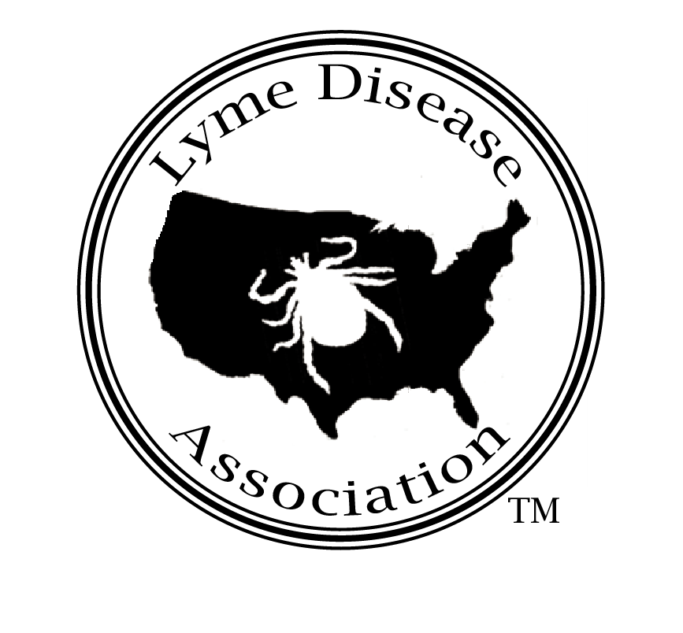
Lyme Disease Association, Inc.
PO Box 1438, Jackson, New Jersey 08527
888-366-6611 Lymeliter@aol.com 732-938-7215 (Fax)
LymeDiseaseAssociation.org

LDA EDUCATIONAL GRANT APPLICATION

PART I

Contact Person:

1. Name & Title

Address

Telephone Number with area code (Day) (Evening)
Fax Number e-Mail address
2. Title of Educational Project and type (publication, seminar, CME conference, etc.)

- Name, Title, Position of Individual Responsible for Project

- Name and address of institution/organization associated with project, if applicable

- Goals and objectives pertaining to chronic Lyme disease

- Timetable for the entire project

- Timetable for the portion of the project to be funded

8. Cost of the project and the amount of funding requested

9. Other sources of funding and ways in which any financial shortfall will be funded

Initial here_____

PART II.

1. Please Provide:
A. Detailed budget

2. If your project is selected to receive a grant, applicant agrees to provide the following:

A. A detailed financial accounting of all money expended at the end of the project.

B. Permission for the LDA to distribute copies of any published articles resulting from the funded project and to publicize the publication or the activity at its discretion.

C. Acknowledgment of LDA support must accompany any article/poster presentation /conference or other presentation resulting from the funded project and must accompany any publicity surrounding the event or publication, including any website reference to the project.

D. A written project summary must be supplied to LDA on the official letterhead of the organization, institution, or other within 30 days of completion of the educational project.

The Board of Directors of the Lyme Disease Association, Inc. reserves the right to discontinue funding of the educational project and/or request return of ALL funds if the project does not meet the specifications submitted or if the information requested above is not supplied on time as agreed to in the grant application, or if the applicant knowingly supplies false information. Any unused funds shall be returned to the LDA within 60 days of project completion.

The applicant must sign to apply and to receive the grant if awarded. By signing, the applicant signifies s/he has the authority to sign such an agreement and the applicant agrees to all terms of this application and the October 2009 cover letter.

_________________________ ____________ __________________________
Signature of Grant Applicant Date Printed name of applicant

_________________________ ____________ __________________________
LDA President (signature) Date LDA President (printed)

PO Box 1438, Jackson, New Jersey 08527
888-366-6611 Lymeliter@aol.com 732-938-7215 (Fax)
www.LymeDiseaseAssociation.org
Lymeliter@aol.com

Lyme Disease Association, Inc.

PART III

January 2009

Dear Educational Grant Applicant,
The Lyme Disease Association (LDA) appreciates your interest and willingness to produce educational material or conduct forums, seminars or other presentations that could prevent people from developing Lyme and other tick-borne diseases. The LDA awards grant funds in varying amounts. In this packet, you will find an education grant application for you to complete to be considered for funding by the Lyme Disease Association, Inc.

Also on the LDA website under grants, you can find a partial list of grants LDA has awarded from 1992-2009 with resultant research publications and conference presentations.
After completing your grant application, please email, fax or mail completed form to LDA (contact information above). Include all three parts (letter, too) signed, initialed, and dated. Applications may also be considered throughout the year. Mailed or faxed applications must include 10 copies of the application material

Any changes to your grant proposal, if already approved, need to be submitted in writing to LDA and are subject to the approval of the Directors. If you have any questions or concerns, please direct them to Lymeliter@aol.com or 888-366-6611.
The LDA is an all-volunteer non-profit, tax exempt corporation that has raised millions of dollars for Lyme research, prevention, education, and patient support. Two of the most important objectives of the LDA are to prevent and find a cure for chronic Lyme disease.
Sincerely,
Patricia V. Smith
President

Initial here_____ Date_______

